**5.3 fetch-execute cycle**

**Name ___________ class_____________**

1. The table shows six stages in the von Neumann fetch-execute cycle.

Put the stages into the correct sequence by writing the numbers 1 to 6 in the right hand column.

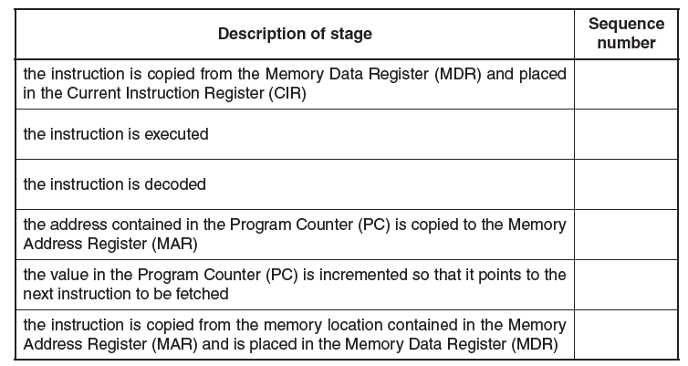

1. **(a)** Describe how special purpose registers are used in the fetch stage of the fetch-execute cycle.

_________________________________________________________________

_________________________________________________________________

_________________________________________________________________

_________________________________________________________________

_________________________________________________________________

_________________________________________________________________

_________________________________________________________________

**(b)** Use the statements A, B, C and D to complete the description of how the fetch-execute cycle handles an interrupt.

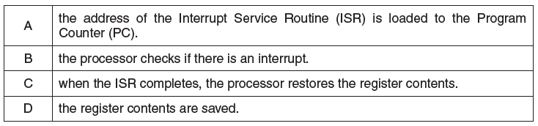

At the end of the cycle for the current instruction__________________ .

If the interrupt flag is set, _____________,____________and ______________

The interrupted program continues its execution.